Lists
Lab: Lists 2
1. Sum Adjacent Equal Numbers 2
2. Gauss' Trick 3
3. Merging Lists 4
4. List of Products 4
5. Remove Negatives and Reverse 7
6. List Manipulation Basics 8
7. List Manipulation Advanced 11
Exercise: Lists 15
1. Train 15
2. Change List 16
3. House Party 17
4. List Operations 18
5. Bomb Numbers 20
6. Cards Game 21
7. Append Arrays 23
8. *Anonymous Threat 23
9. *Pokemon Don't Go 25
10. *SoftUni Course Planning 28
More Exercises: Lists 31
1. Messaging 31
2. Car Race 32
3. Take / Skip Rope 33
4. *Mixed Up Lists 35
5. *Drum Set 36

Lab: Lists
You can check your solutions in Judge

Sum Adjacent Equal Numbers
Create a program to sum all of the adjacent equal numbers in a list of decimal numbers, starting from left to right.
- After two numbers are summed, the result could be equal to some of its neighbors and should be summed as well (see the examples below)
- Always sum the leftmost two equal neighbors (if several couples of equal neighbors are available)

Examples
Input | Output | Explanation
3 3 6 1 | 12 1 | 3 3 6 1 6 6 1 12 1
8 2 2 4 8 16 | 16 8 16 | 8 2 2 4 8 16 8 4 4 8 16 8 8 8 16 16 8 16
5 4 2 1 1 4 | 5 8 4 | 5 4 2 1 1 4 5 4 2 2 4 5 4 4 4 5 8 4

Solution
Read a list of numbers.
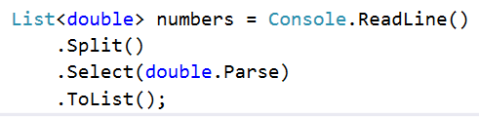
Iterate through the elements. Check if the number at the current index is equal to the next number. If it is, aggregate the numbers and reset the loop, otherwise don't do anything.
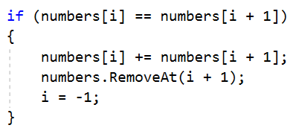
Finally, you have to print the numbers joined by a single space.

Solution
using System;
using System.Collections.Generic;
using System.Linq;

namespace _01.SumAdjacentEqualNumbers
{
internal class Program
{
static void Main(string[] args)
{
List<double> numbers = Console.ReadLine().Split(' ').Select(double.Parse).ToList();
for (int i = 0; i < numbers.Count-1; i++)
{
if (numbers[i] == numbers[i + 1])
{
numbers[i] += numbers[i + 1];
numbers.RemoveAt(i+1);
i=-1;
}
}
Console.WriteLine(string.Join(" ",numbers));
}
}
}

Gauss' Trick
Create a program that sums all numbers in a list in the following order:
first + last, first + 1 + last - 1, first + 2 + last - 2, … first + n, last - n.

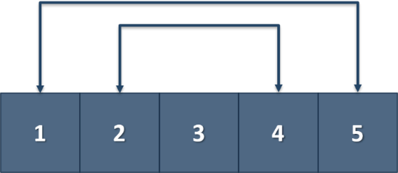

Example
Input | Output
1 2 3 4 5 | 6 6 3
1 2 3 4 | 5 5

solution
using System;
using System.Collections.Generic;
using System.Linq;
namespace _02.GaussTrick
{
internal class Program
{
static void Main(string[] args)
{
List<int> numbers = Console.ReadLine().Split(' ')
.Select(int.Parse).ToList();
List<int> result = new List<int>();
int count = numbers.Count;
for (int i = 0; i < count / 2; i++)
{
result.Add(numbers[i] + numbers[count - 1 - i]);
numbers.RemoveAt(count - 1 - i);
}
if (count % 2 != 0)
{
result.Add(numbers[count / 2]);
}
Console.WriteLine(string.Join(" ",result));
}
}
}

Merging Lists
You are going to receive two lists of numbers. Create a list that contains the numbers from both of the lists. The first element should be from the first list, the second from the second list, and so on. If the length of the two lists is not equal, just add the remaining elements at the end of the list.

Example
Input | Output
3 5 2 43 12 3 54 10 23  76 5 34 2 4 12 | 3 76 5 5 2 34 43 2 12 4 3 12 54 10 23
76 5 34 2 4 12  3 5 2 43 12 3 54 10 23 | 76 3 5 5 34 2 2 43 4 12 12 3 54 10 23

Hint
- Read the two lists.
- Create a result list.
- Start looping through them until you reach the end of the smallest one.
- Finally, add the remaining elements (if there are any) to the end of the list.

Solution
using System;
using System.Collections.Generic;
using System.Linq;
namespace _03.MergingLists
{
internal class Program
{
static void Main(string[] args)
{
List<int> firstList = Console.ReadLine().Split(' ').Select(int.Parse).ToList();
List<int> secondList = Console.ReadLine().Split(' ').Select(int.Parse).ToList();
List<int> mergedList = new List<int>();
int maxLength = Math.Max(firstList.Count, secondList.Count);
for (int i = 0; i < maxLength; i++)
{
if (i < firstList.Count)
{
mergedList.Add(firstList[i]);
}
if (i < secondList.Count)
{
mergedList.Add(secondList[i]);
}
}
Console.WriteLine(string.Join(" ", mergedList));
}
}
}

List of Products
Read a number n and n lines of products. Print a numbered list of all the products ordered by name.

Examples
Input | Output
4  Potatoes  Tomatoes  Onions  Apples | 1.Apples  2.Onions  3.Potatoes  4.Tomatoes
5  Carrots  Artichokes  Beans  Eggplants  Peppers | 1.Artichokes  2.Beans  3.Carrots  4.Eggplants  5.Peppers

Solution
First, we need to read the number n from the console.
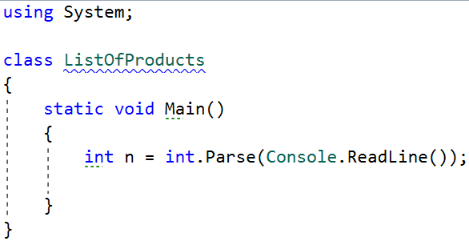
Then we need to create our list of strings, because the products are strings.
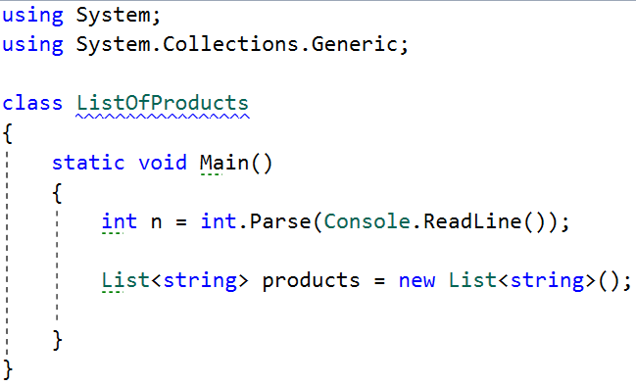
Then we need to iterate n times and read our current product.
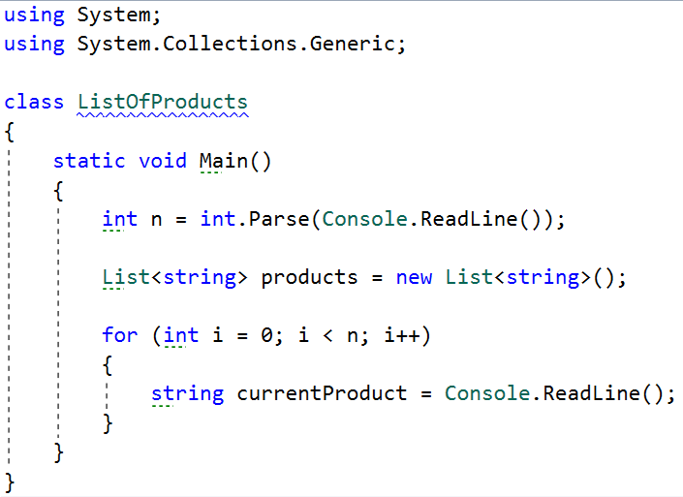
The next step is to add the current product to the list.
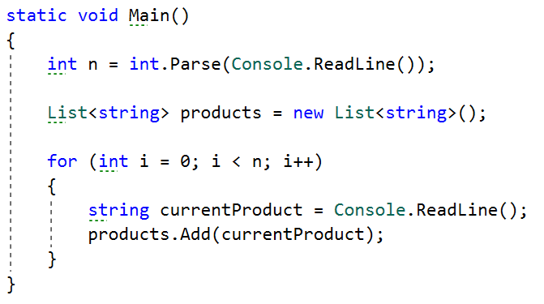
After we finish reading the products, we sort our list alphabetically.
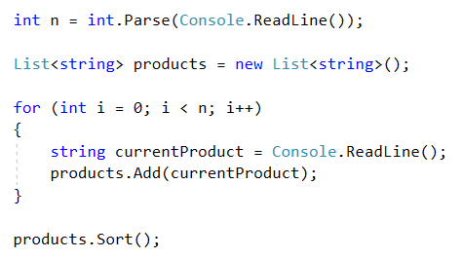
- The sort method sorts the list in ascending order.
Finally, we have to print our sorted list. To do that we loop through the list.
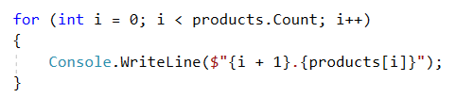
- We use i + 1 because we want to start counting from 1, we put the '.', and finally, we put the actual product.

Solution
using System;
using System.Collections.Generic;
using System.Linq;

namespace _04.ListOfProducts
{
internal class Program
{
static void Main(string[] args)
{
int n = int.Parse(Console.ReadLine());
List<string> products = new List<string>();
for (int i = 0; i < n; i++)
{
string product = Console.ReadLine();
products.Add(product);
}
products.Sort();
for (int i = 0; i < products.Count; i++)
{
Console.WriteLine($"{i + 1}.{products[i]}");
}
}
}
}

Remove Negatives and Reverse
Read a list of integers, remove all negative numbers from it and print the remaining elements in reversed order. If there are no elements left in the list, print "empty".

Examples
Input | Output
10 -5 7 9 -33 50 | 50 9 7 10
7 -2 -10 1 | 1 7
-1 -2 -3 | empty

Solution
Read a list of integers.
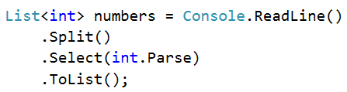
Remove all negative numbers.
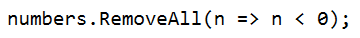
If the list count is equal to 0, print "empty", otherwise print all numbers joined by space.
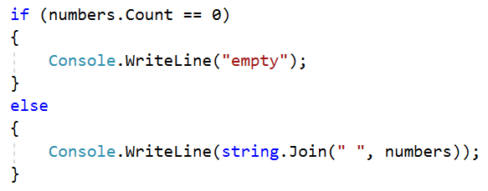

Solution
using System;
using System.Collections.Generic;
using System.Linq;

namespace _05.RemoveNegativesAndReverse
{
internal class Program
{
static void Main(string[] args)
{
List<int> numbers = Console.ReadLine().Split(' ').Select(int.Parse).ToList();
// Remove negative numbers
int count = numbers.Count;
for (int i = 0; i < count; i++)
{
if (numbers[i] < 0)
{
numbers.RemoveAt(i);
i--; // Adjust index after removal
count--; // Decrease count since we removed an element
}
}
// Reverse the list
numbers.Reverse();
// Check if the list is empty
if (numbers.Count == 0)
{
Console.WriteLine("empty");
}
else
{
// Print the reversed list
Console.WriteLine(string.Join(" ", numbers));
}
}
}
}

List Manipulation Basics
Create a program that reads a list of integers. Then until you receive "end", you will receive different commands:
- Add {number}: add a number to the end of the list.
- Remove {number}: remove a number from the list.
- RemoveAt {index}: remove a number at a given index.
- Insert {number} {index}: insert a number at a given index.
Note: All the indices will be valid!
When you receive the "end" command, print the final state of the list (separated by spaces).

Example
Input | Output
4 19 2 53 6 43  Add 3  Remove 2  RemoveAt 1  Insert 8 3  end | 4 53 6 8 43 3 | 23 1 456 63 32 87 9 32  Remove 5  Add 1  Insert 14 2  RemoveAt 3  Add 34  end | 23 1 14 63 32 87 9 32 1 34

Solution
First let us read the list from the console.
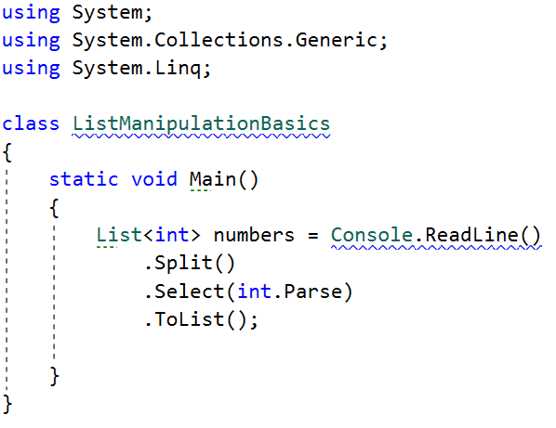
- We split the string we have received from the console, then we loop through each of the elements and parse them to integers.
- This returns IEnumerable<int> (a collection of integers) and we have to keep it in the form of a list.
Next, we go through the input using a while loop and a switch case statement for the different commands.
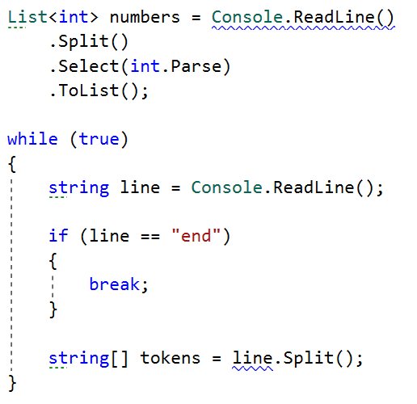
- We stop the cycle, if the line is ended, otherwise, we split the input string into tokens.
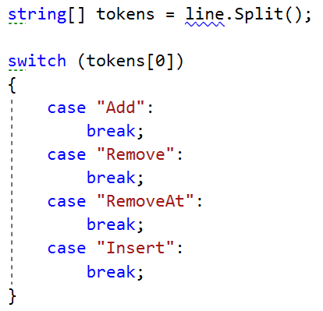
Now, let us implement each of the commands.
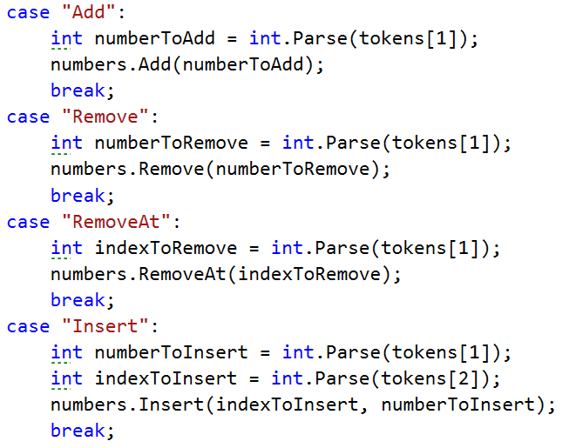
- For each of the commands, except "Insert", tokens[1] is the number / index.
- For the "Insert" command we receive a number and an index (tokens[1], tokens[2]).
Finally, we print the numbers, joined by a single space.

Solution
using System;
using System.Collections.Generic;
using System.Linq;

namespace _06.ListManipulationBasics
{
internal class Program
{
static void Main(string[] args)
{
List<int> numbers = Console.ReadLine().Split(' ').Select(int.Parse).ToList();
string command = Console.ReadLine();
while (command != "end")
{
string[] commandParts = command.Split(' ');
string action = commandParts[0];
switch (action)
{
case "Add":
int numberToAdd = int.Parse(commandParts[1]);
numbers.Add(numberToAdd);
break;
case "Remove":
int numberToRemove = int.Parse(commandParts[1]);
numbers.Remove(numberToRemove);
break;
case "RemoveAt":
int indexToRemove = int.Parse(commandParts[1]);
numbers.RemoveAt(indexToRemove);
break;
case "Insert":
int numberToInsert = int.Parse(commandParts[1]);
int indexToInsert = int.Parse(commandParts[2]);
numbers.Insert(indexToInsert, numberToInsert);
break;
}
command = Console.ReadLine();
}
Console.WriteLine(string.Join(" ", numbers));
}
}
}

List Manipulation Advanced
Next, we are going to implement more complicated list commands, extending the previous task. Again, read a list and keep reading commands until you receive "end":
- Contains {number} – check if the list contains the number and if so - print "Yes", otherwise print "No such number".
- PrintEven – print all the even numbers, separated by a space.
- PrintOdd – print all the odd numbers, separated by a space.
- GetSum – print the sum of all the numbers.
- Filter {condition} {number} – print all the numbers that fulfill the given condition. The condition will be either '<', '>', ">=", "<=".
After the end command, print the list only if you have made some changes to the original list. Changes are made only from the commands from the previous task.

Example
Input | Output
5 34 678 67 5 563 98  Contains 23  PrintOdd  GetSum  Filter >= 21  end | No such number  5 67 5 563  1450  34 678 67 563 98 | 2 13 43 876 342 23 543  Contains 100  Contains 543  PrintEven  PrintOdd  GetSum  Filter >= 43  Filter < 100  end | No such number  Yes  2 876 342  13 43 23 543  1842  43 876 342 543  2 13 43 23

solution
using System;
using System.Collections.Generic;
using System.Linq;

namespace _07.ListManipulationAdvanced
{
internal class Program
{
static void Main(string[] args)
{
//INPUT
List<int> numbers = Console.ReadLine().Split().Select(int.Parse).ToList();
//ACTION
string command = string.Empty;
bool madeChanges = false;
while ((command = Console.ReadLine()) != "end")
{
if (command.Contains("Add") == true)
{
madeChanges = true;
string[] commandArray = command.Split();
int value = int.Parse(commandArray[1]);
//Return Value:
numbers.Add(value);
}
else if (command.Contains("RemoveAt") == true)
{
madeChanges = true;
string[] commandArray = command.Split();
int index = int.Parse(commandArray[1]);
//Return Value:
numbers.RemoveAt(index);
}
else if (command.Contains("Remove") == true)
{
madeChanges = true;
string[] commandArray = command.Split();
int value = int.Parse(commandArray[1]);
numbers.Remove(value); //Return Value
}
else if (command.Contains("Insert") == true)
{
madeChanges = true;
string[] commandArray = command.Split();
int value = int.Parse(commandArray[1]);
int index = int.Parse(commandArray[2]);
numbers.Insert(index, value); //Return Value
}
else if (command.Contains("Contains") == true)
{
string[] commandArray = command.Split();
int value = int.Parse(commandArray[1]);
if (numbers.Contains(value)) //Return Value:
{
Console.WriteLine("Yes");
}
else
{
Console.WriteLine("No such number");
}
}
else if (command == "PrintEven")
{
List<int> evenNumbersList = new List<int>();
for (int i = 0; i < numbers.Count; i++)
{
if (numbers[i] % 2 == 0)
{
evenNumbersList.Add(numbers[i]);
}
}
Console.WriteLine(String.Join(" ", evenNumbersList));
}
else if (command == "PrintOdd")
{
List<int> oddNumbersList = new List<int>();
for (int i = 0; i < numbers.Count; i++)
{
if (numbers[i] % 2 == 1)
{
oddNumbersList.Add(numbers[i]);
}
}
Console.WriteLine(String.Join(" ", oddNumbersList));
}
else if (command == "GetSum")
{
Console.WriteLine(numbers.Sum());
}
else if (command.Contains("Filter") == true)
{
string[] commandArray = command.Split();
string condition = commandArray[1];
int value = int.Parse(commandArray[2]);

List<int> conditionNumbersList = new List<int>();

//Return Value
if (condition == "<")
{
for (int i = 0; i < numbers.Count; i++)
{
if (numbers[i] < value)
{
conditionNumbersList.Add(numbers[i]);
}
}
}
else if (condition == ">")
{
for (int i = 0; i < numbers.Count; i++)
{
if (numbers[i] > value)
{
conditionNumbersList.Add(numbers[i]);
}
}
}
else if (condition == ">=")
{
for (int i = 0; i < numbers.Count; i++)
{
if (numbers[i] >= value)
{
conditionNumbersList.Add(numbers[i]);
}
}
}
else if (condition == "<=")
{
for (int i = 0; i < numbers.Count; i++)
{
if (numbers[i] <= value)
{
conditionNumbersList.Add(numbers[i]);
}
}
}
Console.WriteLine(String.Join(" ", conditionNumbersList));
}
}
//Original List Changes Checker
if (madeChanges == true)
{
Console.WriteLine(String.Join(" ", numbers));
}
}
}
}

Exercise: Lists
- You can check your solutions in Judge
- Ask your questions here https://www.slido.com/ by entering the code #fund-csharp

Train
On the first line, we will receive a list of wagons (integers). Each integer represents the number of passengers that are currently in each wagon of the passenger train. On the next line, you will receive the max capacity of a wagon, represented as a single integer. Until you receive the "end" command, you will be receiving two types of input:
- Add {passengers} – add a wagon to the end of the train with the given number of passengers.
- {passengers} – find a single wagon to fit all the incoming passengers (starting from the first wagon).
In the end, print the final state of the train (all the wagons separated by a space).

Example
Input | Output
32 54 21 12 4 0 23  75  Add 10  Add 0  30  10  75  end | 72 54 21 12 4 75 23 10 0 | 0 0 0 10 2 4  10  Add 10  10  10  10  8  6  end | 10 10 10 10 10 10 10

Solution
using System;
using System.Collections.Generic;
using System.Linq;

namespace _01.Train
{
internal class Program
{
static void Main(string[] args)
{

List<int> train = Console.ReadLine().Split(' ').Select(int.Parse).ToList();

int maxCapacity = int.Parse(Console.ReadLine());
string command;
while ((command = Console.ReadLine()) != "end")
{
string[] parts = command.Split(' ');
if (parts[0] == "Add")
{
int wagon = int.Parse(parts[1]);
train.Add(wagon);
}
else
{
int passengers = int.Parse(parts[0]);
for (int i = 0; i < train.Count; i++)
{
if (train[i] + passengers <= maxCapacity)
{
train[i] += passengers;
break;
}
}
}
}
Console.WriteLine(string.Join(" ", train));
}
}
}

Change List
Create a program, that reads a list of integers from the console and receives commands to manipulate the list.
Your program may receive the following commands:
- Delete {element} – delete all elements in the array, which are equal to the given element.
- Insert {element} {position} – insert the element at the given position.
You should exit the program when you receive the "end" command. Print all numbers in the array, separated by a single whitespace.

Examples
Input | Output
1 2 3 4 5 5 5 6  Delete 5  Insert 10 1  Delete 5  end | 1 10 2 3 4 6
20 12 4 319 21 31234 2 41 23 4  Insert 50 2  Insert 50 5  Delete 4  end | 20 12 50 319 50 21 31234 2 41 23

Solution
using System;
using System.Collections.Generic;
using System.Linq;

namespace _02.ChangeList
{
internal class Program
{
static void Main(string[] args)
{
List<int> numbers = Console.ReadLine().Split(' ').Select(int.Parse).ToList();
string command;
while ((command = Console.ReadLine()) != "end")
{
string[] parts = command.Split(' ');
if (parts[0] == "Delete")
{
int elementToRemove = int.Parse(parts[1]);
numbers.RemoveAll(n => n == elementToRemove);
}
else if (parts[0] == "Insert")
{
int elementToInsert = int.Parse(parts[1]);
int position = int.Parse(parts[2]);
numbers.Insert(position, elementToInsert);
}
}
Console.WriteLine(string.Join(" ", numbers));
}
}
}

House Party
Create a program that keeps track of the guests that are going to a house party. On the first line, of input you are going to receive the number of commands that will follow.
On the next lines, you are going to receive some of the following: "{name} is going!"
- You have to add the person, if they are not on the guestlist already.
- If the person is on the list print the following to the console: "{name} is already in the list!"
"{name} is not going!"
- You have to remove the person, if they are on the list.
- If not, print out: "{name} is not in the list!"
Finally, print all of the guests, each on a new line.

Examples
Input | Output
4  Allie is going!  George is going!  John is not going!  George is not going! | John is not in the list!  Allie | 5  Tom is going!  Annie is going!  Tom is going!  Garry is going!  Jerry is going! | Tom is already in the list!  Tom  Annie  Garry  Jerry

Solution
using System;
using System.Collections.Generic;
using System.Linq;

namespace _03.HouseParty
{
internal class Program
{
static void Main(string[] args)
{
int n = int.Parse(Console.ReadLine());
List<string> guests = new List<string>();
for (int i = 0; i < n; i++)
{
string command = Console.ReadLine();
string[] parts = command.Split(' ');
string name = parts[0];
//is going to party
if (parts.Length == 3 && parts[2] == "going!")
{
if (!guests.Contains(name))
{
guests.Add(name);
}
else
{
Console.WriteLine($"{name} is already in the list!");
}
}
//is not going to party
else if (parts.Length == 4 && parts[2] == "not" && parts[3] == "going!")
{
if (guests.Contains(name))
{
guests.Remove(name);
}
else
{
Console.WriteLine($"{name} is not in the list!");
}
}
}
foreach (var guest in guests)
{
Console.WriteLine(guest);
}
}
}
}

List Operations
The first input line will hold a list of integers. Until we receive the "End" command, we will be given operations we have to apply to the list.
The possible commands are:
- Add {number} – add the given number to the end of the list
- Insert {number} {index} – insert the number at the given index
- Remove {index} – remove the number at the given index
- Shift left {count} – first number becomes last. This has to be repeated the specified number of times
- Shift right {count} – last number becomes first. To be repeated the specified number of times
Note: the index given may be outside of the bounds of the array. In that case print: "Invalid index".

Examples
Input | Output
1 23 29 18 43 21 20  Add 5  Remove 5  Shift left 3  Shift left 1  End | 43 20 5 1 23 29 18 | 5 12 42 95 32 1  Insert 3 0  Remove 10  Insert 8 6  Shift right 1  Shift left 2  End | Invalid index  5 12 42 95 32 8 1 3

Solution
using System;
using System.Collections.Generic;
using System.Linq;

namespace _04.ListOperations
{
internal class Program
{
static void Main(string[] args)
{
List<int> numbers = Console.ReadLine().Split(' ').Select(int.Parse).ToList();
string command;
while ((command = Console.ReadLine()) != "End")
{
string[] parts = command.Split(' ');
switch (parts[0])
{
case "Add":
int numberToAdd = int.Parse(parts[1]);
numbers.Add(numberToAdd);
break;
case "Insert":
int numberToInsert = int.Parse(parts[1]);
int position = int.Parse(parts[2]);
if (position >= 0 && position < numbers.Count)
{
numbers.Insert(position, numberToInsert);
}
else
{
Console.WriteLine("Invalid index");
}
break;
case "Remove":
int indexToRemove = int.Parse(parts[1]);
if (indexToRemove >= 0 && indexToRemove < numbers.Count)
{
numbers.RemoveAt(indexToRemove);
}
else
{
Console.WriteLine("Invalid index");
}
break;
case "Shift":
string direction = parts[1];
int count = int.Parse(parts[2]);

if (direction == "left")
{
for (int i = 0; i < count; i++)
{
numbers.Add(numbers[0]);
numbers.RemoveAt(0);
}
}
else if (direction == "right")
{
for (int i = 0; i < count; i++)
{
numbers.Insert(0, numbers[numbers.Count - 1]);
numbers.RemoveAt(numbers.Count - 1);
}
}
break;
}
}
Console.WriteLine(string.Join(" ", numbers));
}
}
}

Bomb Numbers
Create a program that reads a sequence of numbers and a special bomb number holding a certain power. Your task is to detonate every occurrence of the special bomb number and according to its power the numbers to its left and right. The bomb power refers to how many numbers to the left and right will be removed, no matter their values. Detonations are performed from left to right and all the detonated numbers disappear. Finally, print the sum of the remaining elements in the sequence.

Examples
Input | Output | Comments
1 2 2 4 2 2 2 9  4 2 | 12 | The special number is 4 with power 2. After detonation, we are left with the sequence [1, 2, 9] with sum 12.
1 4 4 2 8 9 1  9 3 | 5 | The special number is 9 with power 3. After detonation, we are left with the sequence [1, 4] with sum 5. Since the 9 has only 1 neighbor from the right we remove just it (one number instead of 3).
1 7 7 1 2 3  7 1 | 6 | Detonations are performed from left to right. We cannot detonate the second occurrence of 7, because it's already destroyed by the first occurrence. The numbers [1, 2, 3] survive. Their sum is 6.
1 1 2 1 1 1 2 1 1 1  2 1 | 4 | The red and yellow numbers disappear in two sequential detonations. The result is the sequence [1, 1, 1, 1]. Sum = 4.

Solution
using System;
using System.Collections.Generic;
using System.Linq;

namespace _05.BombNumbers
{
internal class Program
{
static void Main(string[] args)
{
List<int> numbers = Console.ReadLine().Split(' ').Select(int.Parse).ToList();
int[] bombInfo = Console.ReadLine().Split(' ').Select(int.Parse).ToArray();
int bombNumber = bombInfo[0];
int bombPower = bombInfo[1];
for (int i = 0; i < numbers.Count; i++)
{
if (numbers[i] == bombNumber)
{
int startIndex = Math.Max(0, i - bombPower);
int endIndex = Math.Min(numbers.Count - 1, i + bombPower);
for (int j = endIndex; j >= startIndex; j--)
{
numbers.RemoveAt(j);
}
i = startIndex - 1; // Adjust index after removal
}
}
Console.WriteLine(numbers.Sum());
}
}
}

Cards Game
You will be given two hands of cards, which will be represented by integers. Assume each one is held by a different player. You have to find which one has the winning deck. You start from the beginning of both hands of cards. Compare the cards from the first deck to the cards from the second deck. The player, who holds the more powerful card on the current iteration, takes both cards and puts them at the back of his hand - the second player's card is placed last and the first person's card (the winning one) comes after it (second to last). If both players' cards have the same values - no one wins and the two cards must be removed from both hands. The game is over only when one of the decks is left without any cards. You have to display the result on the console and the sum of the remaining cards: "{First/Second} player wins! Sum: {sum}".

Examples
Input | Output
20 30 40 50  10 20 30 40 | First player wins! Sum: 240
10 20 30 40 50  50 40 30 30 10 | Second player wins! Sum: 50

Solution
using System;
using System.Collections.Generic;
using System.Linq;

namespace _06.CardsGame
{
internal class Program
{
static void Main(string[] args)
{
List<int> firstPlayerCards = Console.ReadLine().Split(' ').Select(int.Parse).ToList();
List<int> secondPlayerCards = Console.ReadLine().Split(' ').Select(int.Parse).ToList();
while (firstPlayerCards.Count > 0 && secondPlayerCards.Count > 0)
{
int firstCard = firstPlayerCards[0];
int secondCard = secondPlayerCards[0];
if (firstCard > secondCard)
{
firstPlayerCards.Add(firstCard);
firstPlayerCards.Add(secondCard);
}
else if (secondCard > firstCard)
{
secondPlayerCards.Add(secondCard);
secondPlayerCards.Add(firstCard);
}
firstPlayerCards.RemoveAt(0);
secondPlayerCards.RemoveAt(0);
}
if (firstPlayerCards.Count > 0)
{
Console.WriteLine($"First player wins! Sum: {firstPlayerCards.Sum()}");
}
else
{
Console.WriteLine($"Second player wins! Sum: {secondPlayerCards.Sum()}");
}

}
}
}

Append Arrays
Create a program to append several arrays of numbers one after another.
- Arrays are separated by '|'
- Their values are separated by spaces (' ', one or several)
- Take all arrays starting from the rightmost and going to the left and place them in a new array in that order

Examples
Input | Output
1 2 3 |4 5 6 | 7 8 | 7 8 4 5 6 1 2 3
7 | 4 5|1 0| 2 5 |3 | 3 2 5 1 0 4 5 7
1| 4 5 6 7 | 8 9 | 8 9 4 5 6 7 1

Solution
using System;
using System.Collections.Generic;
using System.Linq;

namespace _07.AppendArrays
{
internal class Program
{
static void Main(string[] args)
{
List<string> input = Console.ReadLine().Split('|').ToList();
input.Reverse(); // Reverse the list to process from the last element to the first
List<int> result = new List<int>();
foreach (var item in input)
{
List<int> numbers = item.Split(' ', StringSplitOptions.RemoveEmptyEntries)
.Select(int.Parse)
.ToList();
result.AddRange(numbers);
}

Console.WriteLine(string.Join(" ", result));
}
}
}

*Anonymous Threat
Anonymous has created a cyber hyper virus, which steals data from the CIA. You, as the lead security developer in the CIA, have been tasked to analyze the software of the virus and observe its actions on the data. The virus is known for its innovative and unbelievably clever technique of merging and dividing data into partitions.
You will receive a single input line, containing strings, separated by spaces. The strings may contain any ASCII character except whitespace. Then you will begin receiving commands in one of the following formats:
- merge {startIndex} {endIndex}
- divide {index} {partitions}
Every time you receive the merge command, you must merge all elements from the startIndex to the endIndex. In other words, you should concatenate them.
Example: {abc, def, ghi} -> merge 0 1 -> {abcdef, ghi}
If any of the given indexes is out of the array, you must take only the range that is inside the array and merge it.
Every time you receive the divide command, you must divide the element at the given index, into several small substrings with equal length. The count of the substrings should be equal to the given partitions.
Example: {abcdef, ghi, jkl} -> divide 0 3 -> {ab, cd, ef, ghi, jkl}
If the string cannot be exactly divided into the given partitions, make all partitions except the last with equal lengths and make the last one – the longest.
Example: {abcd, efgh, ijkl} -> divide 0 3 -> {a, b, cd, efgh, ijkl}
The input ends when you receive the command "3:1". At that point, you must print the resulting elements, joined by a space.

Input
- The first input line will contain the array of data.
- On the next several input lines, you will receive commands in the format specified above.
- The input ends when you receive the command "3:1".

Output
- As output, you must print a single line containing the elements of the array, joined by a space.

Constrains
- The strings in the array may contain any ASCII character except whitespace.
- The startIndex and the endIndex will be in the range [-1000…1000].
- The endIndex will always be greater than the startIndex.
- The index in the divide command will always be inside the array.
- The partitions will be in the range [0…100].
- Allowed working time/memory: 100ms / 16MB.

Examples
Input | Output
Ivo Johny Tony Bony Mony  merge 0 3  merge 3 4  merge 0 3  3:1 | IvoJohnyTonyBonyMony
abcd efgh ijkl mnop qrst uvwx yz  merge 4 10  divide 4 5  3:1 | abcd efgh ijkl mnop qr st uv wx yz

Solution
using System;
using System.Collections.Generic;
using System.Linq;

namespace _08.AnonymousThreat
{
internal class Program
{
static void Main(string[] args)
{
List<string> input = Console.ReadLine()
.Split(' ', StringSplitOptions.RemoveEmptyEntries)
.ToList();
string command = Console.ReadLine();
while (command != "3:1")
{
string[] commandParts = command.Split(' ', StringSplitOptions.RemoveEmptyEntries);
string action = commandParts[0];
int index1 = int.Parse(commandParts[1]);
int index2 = int.Parse(commandParts[2]);
if (action == "merge")
{

index1 = Math.Clamp(index1,0, input.Count-1);
index2 = Math.Clamp(index2, 0, input.Count - 1); ;
List<string> mergedElements = input.GetRange(index1,index2-index1+1);
input.RemoveRange(index1, index2-index1+1);
string mergedString = string.Join("", mergedElements);
input.Insert(index1, mergedString);

}
else if (action == "divide")
{
if (index1 < 0 || index1 >= input.Count || index2 <= 0) continue;
string elementToDivide = input[index1];
int partLength = elementToDivide.Length / index2;
List<string> dividedParts = new List<string>();
for (int i = 0; i < index2; i++)
{
int startIndex = i * partLength;
int length = (i == index2 - 1) ? elementToDivide.Length - startIndex : partLength;
dividedParts.Add(elementToDivide.Substring(startIndex, length));
}
input.RemoveAt(index1);
input.InsertRange(index1, dividedParts);
}
command = Console.ReadLine();
}
Console.WriteLine(string.Join(" ", input));
}
}
}

*Pokemon Don't Go
Ely likes to play Pokemon Go a lot. But Pokemon Go bankrupted… So the developers made Pokemon Don't Go out of depression. And so Ely now plays Pokemon Don't Go. In Pokemon Don't Go, when you walk to a certain pokemon, those closest to you, naturally get further, and those further from you, get closer.
You will receive a sequence of integers, separated by spaces – the distances to the pokemon. Then you will begin receiving integers, which will correspond to indexes in that sequence.
When you receive an index, you must remove the element at that index from the sequence (as if you've captured the pokemon).
- You must increase the value of all elements in the sequence, which are less or equal to the removed element, with the value of the removed element.
- You must decrease the value of all elements in the sequence, which are greater than the removed element, with the value of the removed element.
If the given index is less than 0, remove the first element of the sequence, and copy the last element to its place.
If the given index is greater than the last index of the sequence, remove the last element from the sequence, and copy the first element to its place.
The increasing and decreasing of elements should be done in these cases, also. The element, whose value you should use, is the removed element.
The program ends when the sequence has no elements (there are no pokemon left for Ely to catch).

Input
- On the first line of input you will receive a sequence of integers, separated by spaces.
- On the next several lines, you will receive integers – the indexes.

Output
- When the program ends, you must print the summed value of all removed elements.

Constrains
- The input data will consist only of valid integers in the range [-2.147.483.648…2.147.483.647].

Examples
Input | Output | Comments
4 5 3  1  1  0 | 14 | The array is {4, 5, 3}. The index is 1.  We remove 5, and we increase all the lower ones and decrease all the higher ones.  In this case, there are no higher than 5.  The result is {9, 8}.  The index is 1. So we remove 8 and decrease all the higher ones.  The result is {1}.  The index is 0. So we remove 1.  There are no elements left, so we print the sum of all removed elements.  5 + 8 + 1 = 14.
5 10 6 3 5  2  4  1  1  3  0  0 | 51 | Step 1: {11, 4, 9, 11}  Step 2: {22, 15, 20, 22}  Step 3: {7, 5, 7}  Step 4: {2, 2}  Step 5: {4, 4}  Step 6: {8}  Step 7: {} (empty).  Result = 6 + 11 + 15 + 5 + 2 + 4 + 8 = 51.

Solution
using System;
using System.Collections.Generic;
using System.Linq;

namespace _09.PokemonDontGo
{
internal class Program
{
static void Main(string[] args)
{
List<int> pokemons = Console.ReadLine()
.Split(' ')
.Select(int.Parse)
.ToList();
int totalSum = 0;
// Докато списъкът не е празен
while (pokemons.Count > 0)
{
int index = int.Parse(Console.ReadLine());
int removedValue;
// Ако индексът е по-малък от 0
if (index < 0)
{
removedValue = pokemons[0];
totalSum += removedValue;
// Копираме последния елемент на мястото на първия
pokemons[0] = pokemons[pokemons.Count - 1];
}
// Ако индексът е по-голям от последния валиден
else if (index >= pokemons.Count)
{
removedValue = pokemons[pokemons.Count - 1];
totalSum += removedValue;
// Копираме първия елемент на мястото на последния
pokemons[pokemons.Count - 1] = pokemons[0];
}
// В противен случай – нормално премахване
else
{
removedValue = pokemons[index];
totalSum += removedValue;
pokemons.RemoveAt(index);
}
// Обработваме останалите елементи
for (int i = 0; i < pokemons.Count; i++)
{
if (pokemons[i] <= removedValue)
{
pokemons[i] += removedValue;
}
else
{
pokemons[i] -= removedValue;
}
}
}
Console.WriteLine(totalSum); // Печатаме общата стойност на хванатите покемони
}
}
}

*SoftUni Course Planning
Help planning the next Programming Fundamentals course by keeping track of the lessons that will be included in the course, as well as all the exercises for the lessons. On the first input line, you will receive the initial schedule of lessons and exercises that are going to be part of the next course, separated by a comma and a space ", ". Before the course starts, there are some changes to be made. Until you receive the "course start" command, you will be given some commands to modify the course schedule.
The possible commands are:
- Add:{lessonTitle} – add the lesson to the end of the schedule, if it does not exist.
- Insert:{lessonTitle}:{index} – insert the lesson to the given index, if it does not exist.
- Remove:{lessonTitle} – remove the lesson, if it exists.
- Swap:{lessonTitle}:{lessonTitle} – swap the position of the two lessons, if they exist.
Exercise:{lessonTitle} – add Exercise in the schedule right after the lesson index, if the lesson exists and there is no exercise already, in the following format "{lessonTitle}-Exercise". If the lesson doesn`t exist, add the lesson at the end of the course schedule, followed by the Exercise.
Note: Each time you Swap or Remove a lesson, you should do the same with the Exercises, if there are any following the lessons.

Input / Constraints
- First line – the initial schedule lessons – strings, separated by comma and space ", ".
- Until "course start" you will receive commands in the format described above.

Output
- Print the whole course schedule, each lesson on a new line with its number (index) in the schedule:
"{lesson index}.{lessonTitle}".
- Allowed working time / memory: 100ms / 16MB.

Examples
Input | Output | Comment
Data Types, Objects, Lists  Add:Databases  Insert:Arrays:0  Remove:Lists  course start | 1.Arrays  2.Data Types  3.Objects  4.Databases | We receive the initial schedule.  Next, we add the Databases lesson, because it doesn't exist.  We Insert at the given index lesson Arrays because it's not present in the schedule.  After receiving the last command and removing lesson Lists, we print the whole schedule.
Input | Output | Comment
Arrays, Lists, Methods  Swap:Arrays:Methods  Exercise:Databases  Swap:Lists:Databases  Insert:Arrays:0  course start | 1.Methods  2.Databases  3.Databases-Exercise  4.Arrays  5.Lists | We swap the given lessons because both exist.  After receiving the Exercise command, we see that such a lesson doesn`t exist, so we add the lesson at the end, followed by the exercise.  We swap Lists and Databases lessons, the  Databases-Exercise is also moved after the Databases lesson.  We skip the next command because we already have such a lesson in our schedule.

Solution
using System;
using System.Collections.Generic;
using System.Linq;
namespace _10.SoftUniCoursePlanning
{
internal class Program
{
static void Main(string[] args)
{
// Четем началния график (разделени със ", ")
List<string> schedule = Console.ReadLine()
.Split(", ", StringSplitOptions.RemoveEmptyEntries)
.ToList();
string input;
while ((input = Console.ReadLine()) != "course start")
{
string[] parts = input.Split(':');
string command = parts[0];
string lessonTitle = parts[1];
switch (command)
{
case "Add":
if (!schedule.Contains(lessonTitle))
schedule.Add(lessonTitle);
break;
case "Insert":
int index = int.Parse(parts[2]);
if (!schedule.Contains(lessonTitle) && index >= 0 && index <= schedule.Count)
schedule.Insert(index, lessonTitle);
break;
case "Remove":
schedule.Remove(lessonTitle);
schedule.Remove($"{lessonTitle}-Exercise");
break;
case "Swap":
string lesson2 = parts[2];
if (schedule.Contains(lessonTitle) && schedule.Contains(lesson2))
{
// Разменяме уроците
int index1 = schedule.IndexOf(lessonTitle);
int index2 = schedule.IndexOf(lesson2);
(schedule[index1], schedule[index2]) = (schedule[index2], schedule[index1]);
// Разменяме упражненията, ако има
string exercise1 = $"{lessonTitle}-Exercise";
string exercise2 = $"{lesson2}-Exercise";
bool hasExercise1 = schedule.Contains(exercise1);
bool hasExercise2 = schedule.Contains(exercise2);
if (hasExercise1)
{
schedule.Remove(exercise1);
schedule.Insert(schedule.IndexOf(lessonTitle) + 1, exercise1);
}
if (hasExercise2)
{
schedule.Remove(exercise2);
schedule.Insert(schedule.IndexOf(lesson2) + 1, exercise2);
}
}
break;
case "Exercise":
string exercise = $"{lessonTitle}-Exercise";
if (schedule.Contains(lessonTitle))
{
if (!schedule.Contains(exercise))
{
int lessonIndex = schedule.IndexOf(lessonTitle);
schedule.Insert(lessonIndex + 1, exercise);
}
}
else
{
schedule.Add(lessonTitle);
schedule.Add(exercise);
}
break;
}
}
// Извеждаме финалния списък
for (int i = 0; i < schedule.Count; i++)
{
Console.WriteLine($"{i + 1}.{schedule[i]}");
}
}
}
}

More Exercises: Lists

Messaging
You will be given a list of numbers and a string. For each element of the list you must calculate the sum of its digits and take the element, corresponding to that index from the text. If the index is greater than the length of the text, start counting from the beginning (so that you always have a valid index). After you get that element from the text, you must remove the character you have taken from it (so for the next index the text will be with one characterless).

Example
Input | Output
9992 562 8933  This is some message for you | hey
11 2 32 43 331 522 441 2241 711 1821  69da343n44ge96rous311! | dangerous!

Solution
using System;
using System.Collections.Generic;
using System.Linq;

namespace _01.Messaging
{
internal class Program
{
static void Main(string[] args)
{
List<int> numbers = Console.ReadLine()
.Split(' ', StringSplitOptions.RemoveEmptyEntries)
.Select(int.Parse)
.ToList();
string messages = Console.ReadLine();
List<int> messageIndices = new List<int>();
string result = string.Empty;
for (int i = 0; i < numbers.Count; i++)
{
int currentNumber = 0;
string currentNumberStr = numbers[i].ToString();
for (int j = 0; j < currentNumberStr.Length; j++)
{
currentNumber += int.Parse(currentNumberStr[j].ToString());
}
messageIndices.Add(currentNumber);
}
for (int i = 0; i < messageIndices.Count; i++)
{
if (messageIndices[i] >= messages.Length)
{
messageIndices[i] = messageIndices[i] % messages.Length;
}
}
for (int i = 0; i < messageIndices.Count; i++)
{
result += messages[messageIndices[i]];
messages = messages.Remove(messageIndices[i], 1);
}
Console.WriteLine(result);
// Console.WriteLine(string.Join(" ", messageIndices));
}
}
}

Car Race
Write a program to calculate the winner of a car race. You will receive an array of numbers. Each element of the array represents the time needed to pass through that step (the index). There are going to be two cars. One of them starts from the left side and the other one starts from the right side. The middle index of the array is the finish line. The number of elements in the array will always be odd. Calculate the total time for each racer to reach the finish, which is the middle of the array, and print the winner with his total time (the racer with less time). If you have a zero in the array, you have to reduce the time of the racer that reached it by 20% (from his current time).
Print the result in the following format "The winner is {left/right} with total time: {total time}".

Example
Input | Output
29 13 9 0 13 0 21 0 14 82 12 | The winner is left with total time: 53.8
Comment
The time of the left racer is (29 + 13 + 9) * 0.8 (because of the zero) + 13 = 53.8
The time of the right racer is (82 + 12 + 14) * 0.8 + 21 = 107.4
The winner is the left racer, so we print it
Input | Output
26 46 31 43 1 23 44 | The winner is right with total time: 68

Solution
using System;
using System.Collections.Generic;
using System.Linq;
namespace _02.CarRace
{
internal class Program
{
static void Main(string[] args)
{
List<int> numbers = Console.ReadLine()
.Split(' ', StringSplitOptions.RemoveEmptyEntries)
.Select(int.Parse)
.ToList();
//string direction = Console.ReadLine().ToLower();
double finishLine = numbers.Count / 2;
double leftTime = 0;
double rightTime = 0;
for (int i = 0; i < finishLine; i++)
{
if (numbers[i] == 0)
{
leftTime -= leftTime* 0.2;
}
else
{
leftTime += numbers[i];
}
}
for (int i = numbers.Count - 1; i > finishLine; i--)
{
if (numbers[i] == 0)
{
rightTime -= rightTime* 0.2;
}
else
{
rightTime += numbers[i];
}
}
if (leftTime < rightTime)
{
Console.WriteLine($"The winner is left with total time: {leftTime}");
}
else
{
Console.WriteLine($"The winner is right with total time: {rightTime}");
}
}
}
}

Take / Skip Rope
Write a program, which reads a string and skips through it, extracting a hidden message. The algorithm you have to implement is as follows:
Let's take the string "skipTest_String044170" as an example.
Take every digit from the string and store it somewhere. After that, remove all the digits from the string. After this operation, you should have two lists of items: the numbers list and the non-numbers list:
- Numbers list: [0, 4, 4, 1, 7, 0]
- Non-numbers: [s, k, i, p, T, e, s, t, _, S, t, r, i, n, g]
After that, take every digit in the numbers list and split it up into a take list and a skip list, depending on whether the digit is in an even or an odd index:
- Numbers list: [0, 4, 4, 1, 7, 0]
- Take list: [0, 4, 7]
- Skip list: [4, 1, 0]
Afterward, iterate over both lists and skip {skipCount} characters from the non-numbers list, then take {takeCount} characters and store it in a result string. Note that the skipped characters are summed up as they go. The process would look like this on the aforementioned non-numbers list:
- Take 0 characters Taken: "", skip 4 characters (total 0) Skipped: "skipTest_String" Result: ""
- Take 4 characters Taken: "Test", skip 1 character (total 4) Skipped: "skip" Result: "Test"
- Take 7 characters Taken: "String", skip 0 characters (total 9) Skipped: "" Result: "TestString"
After that, just print the result string on the console.

Input
- First line: The encrypted message as a string

Output
- First line: The decrypted message as a string

Constraints
- The count of digits in the input string will always be even.
- The encrypted message will contain any printable ASCII character.

Examples
Input | Output
T2exs15ti23ng1_3cT1h3e0_Roppe | TestingTheRope
O{1ne1T2021wf312o13Th111xreve!!@! | OneTwoThree!!!
this forbidden mess of an age rating 0127504740 | hidden message

Solution
using System;
using System.Collections.Generic;
using System.Linq;

namespace _03.TakeSkipRope
{
internal class Program
{
static void Main(string[] args)
{
string input = Console.ReadLine();
List<int> numbers = new List<int>();
List<char> letters = new List<char>();
for (int i = 0; i < input.Length; i++)
{
if (char.IsDigit(input[i]))
{
numbers.Add(int.Parse(input[i].ToString()));
}
else
{
letters.Add(input[i]);
}
}
List<int> takeSkip = new List<int>();
for (int i = 0; i < numbers.Count; i += 2)
{
if (i + 1 < numbers.Count)
{
takeSkip.Add(numbers[i]);
takeSkip.Add(numbers[i + 1]);
}
}
string result = string.Empty;
int index = 0;
for (int i = 0; i < letters.Count; i++)
{
if (index < takeSkip.Count)
{
int take = takeSkip[index];
int skip = takeSkip[index + 1];
result += new string(letters.Skip(i).Take(take).ToArray());
i += take + skip - 1; // Adjust index to skip the specified number of characters
index += 2; // Move to the next pair of take/skip
}
else
{
break; // No more take/skip pairs available
}
}
Console.WriteLine(result);
}
}
}

*Mixed Up Lists
Write a program that mixes up two lists by some rules. You will receive two lines of input, each one being a list of numbers. The mixing rules are:
- Start from the beginning of the first list and the ending of the second.
- Add element from the first and element from the second.
- In the end, there will always be a list, in which there are 2 elements are remaining.
- These elements will be the range of the elements you need to print.
- Loop through the result list and take only the elements that fulfill the condition.
- Print the elements ordered in ascending order and separated by a space.

Example
Input | Output
1 5 23 64 2 3 34 54 12  43 23 12 31 54 51 92 | 23 23 31 34 43 51
Comment
After looping through the two of the arrays we get:
1 92 5 51 23 54 64 31 2 12 3 23 34 43
The constraints are 54 and 12 (so we take only the numbers between them): 51 23 31 23 34 43.
We print the result sorted.
Input | Output
87 30 65 23 39  41 85 41 72 46 78 10 | 46 65 72 78

Solution
using System;
using System.Collections.Generic;
using System.Linq;

namespace _04.MixedUpLists
{
internal class Program
{
static void Main(string[] args)
{
List<int> firstList = Console.ReadLine()
.Split(' ', StringSplitOptions.RemoveEmptyEntries).Select(int.Parse).ToList();
List<int> secondList = Console.ReadLine()
.Split(' ', StringSplitOptions.RemoveEmptyEntries).Select(int.Parse).ToList();
List<int> mixedList = new List<int>();
List<int> border = new List<int>();
int minLength = Math.Min(firstList.Count, secondList.Count);
for (int i = 0; i < minLength; i++)
{
mixedList.Add(firstList[i]);
mixedList.Add(secondList[secondList.Count - 1 - i]);
}
if (firstList.Count > minLength)
{
for (int i = minLength; i < firstList.Count; i++)
{
border.Add(firstList[i]);
}
}
if (secondList.Count > minLength)
{
for (int i = 0; i < secondList.Count-firstList.Count ; i++)
{
border.Add(secondList[i]);
}
}
mixedList.Sort();
border.Sort();
List<int>result = new List<int>();
for (int i=0; i < mixedList.Count; i++)
{
if (border.Min() < mixedList[i] && border.Max() > mixedList[i])
{
result.Add(mixedList[i]);
}
}
// Console.WriteLine(string.Join(" ", mixedList));
//Console.WriteLine(string.Join(" ", border));
Console.WriteLine(string.Join(" ", result));
}
}
}

*Drum Set
Gabsy is Orgolt's Final Revenge charming drummer. She has a drum set but the different drums have different origins – some she bought, some are gifts, so they are all of different quality. Every day she practices on each of them, so she does damage and reduces the drum`s quality. Sometimes a drum breaks, so she needs to buy a new one. Help her keep her drum set organized.
You will receive Gabsy's savings, the money she can spend on new drums. Next, you will receive a sequence of integers, which represents the initial quality of each drum in Gabsy's drum set.
Until you receive the command "Hit it again, Gabsy!", you will be receiving an integer: the hit power Gabsy applies on each drum while practicing. When the power is applied, you should decrease the value of the drum's quality with the current power.
When a certain drum reaches 0 quality, it breaks. Then Gabsy should buy a replacement. She needs to buy the same model. Therefore, its quality will be the same as the initial quality of the broken drum. The price is calculated by the formula: {initialQuality} * 3. Gabsy will always replace her broken drums until the moment she can no longer afford them. If she doesn't have enough money for a replacement, the broken drum is removed from the drum set.
When you receive the command "Hit it again, Gabsy!", the program ends and you should print the current state of the drum set. On the second line you should print the remaining money in Gabsy's savings account.

Input
- On the first line, you will receive the savings – a floating-point number.
- On the second line, you will receive the drum set: a sequence of integers, separated by spaces.
- Until you receive the command "Hit it again, Gabsy!", you will be receiving integers – the hit power Gabsy applies on each drum.

Output
- On the first line, you should print each drum in the drum set, separated by space.
- Then you must print the money that is left on the second line in the format "Gabsy has {money left}lv.", formatted with two digits after the decimal point.

Constraints
- The savings – a floating-point number in the range [0.00…10000.00].
- The quality of each drum in the drum set – an integer in the range [1…1000].
- The hit power will be in the range [0…1000].
- Allowed working time / memory: 100ms / 16MB.

Examples
Input | Output | Comment
1000.00  58 65 33  11  12  18  10  Hit it again, Gabsy! | 7 14 23  Gabsy has 901.00lv. | DrumSet – 58 65 33.  Day 1: hit power applied = 11 => 47 54 22;  Day 2: hit power applied = 12 => 35 42 10;  Day 3: hit power applied = 18 => 17 24 -8;  The third drum breaks. But Gabsy has enough savings, so she replaces it => 17 24 33;  Day 4: hit power applied = 10 => 7 14 23;  We print the current state of the drum set and what's left in Gabsy's bank account.
154.00  55 111 3 5 8 50  2  50  8  23  1  Hit it again, Gabsy! | 27 2 4 7  Gabsy has 10.00lv.

solution
using System;
using System.Collections.Generic;
using System.Linq;

namespace _05.DrumSet
{
internal class Program
{
static void Main(string[] args)
{
double initialBudget = double.Parse(Console.ReadLine());
List<int> initialDrumSet = Console.ReadLine()
.Split(' ', StringSplitOptions.RemoveEmptyEntries)
.Select(int.Parse)
.ToList();
List<int> currentDrumSet = new List<int>(initialDrumSet);
string input=Console.ReadLine();
while (input != "Hit it again, Gabsy!")
{
int hitPower = int.Parse(input);
for (int i = 0; i < currentDrumSet.Count; i++)
{
currentDrumSet[i] -= hitPower;
if (currentDrumSet[i] <= 0)
{
if (initialBudget >= initialDrumSet[i] * 3)
{
initialBudget -= initialDrumSet[i] * 3;
currentDrumSet[i] = initialDrumSet[i];
}
else
{
currentDrumSet.RemoveAt(i);
initialDrumSet.RemoveAt(i);
i--; // Adjust index after removal
}
}
}
input = Console.ReadLine();
}
Console.WriteLine(string.Join(" ", currentDrumSet));
Console.WriteLine($"Gabsy has {initialBudget:f2}lv.");
}
}
}

